Work Sample
Contents
Work Sample 1
Question: 1
Solutions : 1
Sol1 :From the data, we can infer that the average price of cameras was the highest in year 2001 and the price was 635.18 1
Sol2:From the data, we can either buy Samsung i7 or Samsung L74 Wide (released in year 2007) 1
Sol3:Part1-From the chart/graph, we can infer that: 1
Comparing charts 3 – Part1, Part2,Part 3 and Part 4, we can infer the following 7
Additional information for questions 1 & 2 8

Question:
Open the cameras.csv file and configure the data in excel to be able to answer the following questions. In question 4, you will take your findings from questions 1-3 and create a short-written report to explain your findings and recommendations.

- In which year was the average price of cameras the highest and what was the average price?
- I would like to buy a camera with the following features at the lowest price. Which camera should I buy?
  - Max resolution should be at least 2550.
  - Dimensions should be greater than 100.
  - Storage Included should be at least 50.
- Group normal focus range into 4 buckets and graph the cameras based on the normal focus range over time (release date). Graph your findings. What can you infer based on the graph?
Take your answers from above and create a word document that explains your answers. Import and discuss any charts and graphs from questions 1-3 from Excel into Word. Save your word document and send this back to Amanda.

Solutions :

Sol1 :From the data, we can infer that the average price of cameras was the highest in year 2001 and the price was 635.18

Sol2:From the data, we can either buy Samsung i7 or Samsung L74 Wide (released in year 2007)

Sol3:Part1-From the chart/graph, we can infer that:
- For normal focus range between 0 and 30(Categorizing into 4 buckets with a range of 30 each), plotting the below graph

e)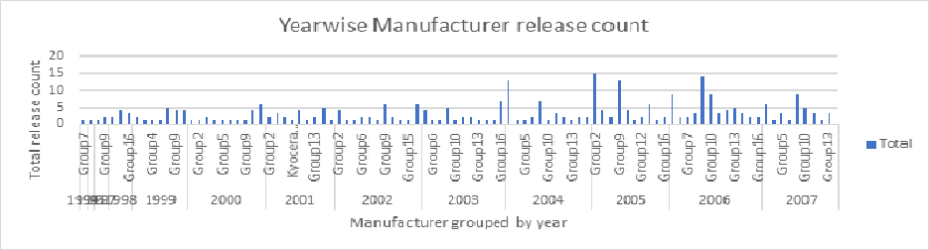
Legend
Group1 | Agfa
Group2 | Cannon
Group3 | Casio
Group4 | Epson
Group5 | Fujifilm
Group6 | HP
Group7 | Kodak
Group8 | Leica
Group9 | Nikon
Group10 | Olympus
Group11 | Panasonic
Group12 | Pentax
Group13 | Ricoh
Group14 | Samsung
Group15 | Sigma
Group16 | Sony

Key callouts:
Generic trend
From a)
- We steadily see an increase in the total number of camera models released from 1994 to 2006 and has a sharp dip in 2007.
- The average of normal focus range has been fairly steady over the years 1994 to 2006 with an average of around 15.

Special variations:
From b)
Manufacturers: Agfa, Contax N Digital, Epson and Sigma had the least average Normal focus range which was 0, while Kyocera had the highest average Normal focus range which was 30 over the years from 1994 to 2007.
From c)
Manufacturer Nikon has made the maximum number of releases (65) during while Contax N Digital, Kyocera, Sanyo and Toshiba have made the least number of releases (1). This was during the period 1994 to 2007.
From d)
Average Normal focus range for all manufacturers was; highest in the year 1997 (22) and the least during the years 1995 & 1994 (0) for the time period 1994 to 2007.
From e)
We can see that manufacturer Cannon made the highest number of releases (15) during the year 2005.

3 Contd. – Part2
- For normal focus range between 31 and 60(Categorizing into 4 buckets with a range of 30 each), plotting the below graph
Note:
I am just doing a high-level analysis this time, in the best interest of time but ideally we can run each of the above analysis to this data set as well.

- From above graph we see steep increase in the total number of camera models released from 1994 to 2006
- The average Normal focus range remains constant over the years 1994 to 2006 with an average of around 45.

3 Contd. – Part3
- For normal focus range between 61 and 90(Categorizing into 4 buckets with a range of 30 each), plotting the below graph
Note:
I am just doing a high level analysis this time, in the best interest of time but ideally we can run each of the above analysis to this data set as well.

- From above graph we see that total number of camera models released from 1994 to 2006 is almost negligible (Close to or is 0)
- The average Normal focus range remains high constant over the years 1994 to 2006 with an average of around 90.

3 Contd. – Part4
- For normal focus range between 91 and 120(Categorizing into 4 buckets with a range of 30 each), plotting the below graph
Note:
I am just doing a high-level analysis this time, in the best interest of time but ideally, we can run each of the above analysis to this data set as well.

- From above graph we see that total number of camera models released from 1994 to 2006 is almost negligible (Close to or is 0)
- The average Normal focus range remains high constant over the years 1994 to 2006 with an average of around 110.

Comparing charts 3 – Part1, Part2,Part 3 and Part 4, we can infer the following :

Part 1 Part 2

Part3 Part4

- Released model count is almost negligible when Normal Focus range is above 60
- When the Normal focus range is between 31 to 60, there is a steady but steep rise in the released model count progressive from 1994 to 2007 but for other ranges of Normal focus range, the released model count remains fairly constant or at most with minor variations.

Additional information for questions 1 & 2

From the graph above, the average price of the product was highest in the year 2001 which was 635.18. On the contrary the least average price of the product were in the years 1994 and 1995 (129) .

Earlier(referring solution 2), 2 products were recommended with the given criteria (Samsung i7 or Samsung L74 Wide), however from the above diving deeper on the individual parameters, we can observe that former is an overall winner as it has a better zoom wide(w) -38, Zoom tele(T)-114 and a lower 101 (more handy) which gives it the edge. Hence, I recommend Samsung i7.

